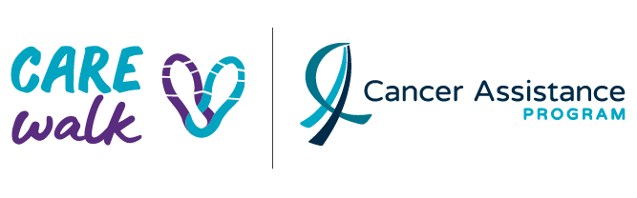

Dear Family and Friends,

The Cancer Assistance Program’s 8th Annual CARE Walk is taking place on Saturday, May 28th, 2022, and I am stepping up! I can participate from anywhere at anytime during the day. This is a cause that is important to me and desperately needed in our community. I am asking for your help in reaching my fundraising goal.

Cancer has not taken a break during these unprecedented times. The Cancer Assistance Program (CAP) is a community-based, not-for-profit organization led by a team of staff and volunteers, offering FREE services to ease the physical, emotional, and economic impact for all those in our community affected by cancer. CAP has been supporting cancer patients and their families for over 28 years with practical and essential services that help cancer patients live at home while receiving treatment.

With no sustainable government funding, CAP is challenged each year with raising more funds
to meet our community’s demand and we cannot do it alone. CAP relies greatly on the generous support of the community and proceeds raised from signature events held throughout the year - every dollar helps! Proceeds raised ensure CAP can continue providing FREE practical supports to cancer patients and families in our community during an especially challenging time. Your support will provide help when it is needed most.

Click HERE to make a donation towards my fundraising goal. You can find me under “Individual or Team Name”.

Thank you for your consideration and support!
Your Name

