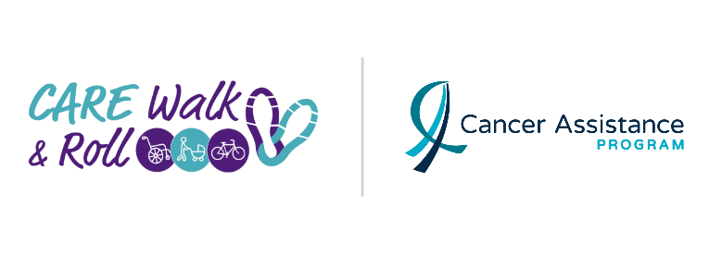
Saturday, May 25, 2024

Dear Family and Friends,

Join me in supporting the Cancer Assistance Program's 10th Annual CARE Walk & Roll, Saturday, May 25, 2024! I can participate anywhere, anytime during the day or join one of the Meet Up Locations across the city. This cause is close to my heart, and I'd love your help in reaching my fundraising goal.

Cancer hasn't stopped during these tough times. The Cancer Assistance Program (CAP) has been tirelessly supporting the Greater Hamilton community for over 30 years, providing FREE services to those affected by cancer. With no sustainable government funding, CAP relies on the generosity of people like you to continue their vital work.

Every dollar counts! Your support ensures CAP can keep providing practical help to cancer patients and families when they need it most. Let's make a difference together!

Click HERE to donate towards my fundraising goal. You can find me under “Individual or Team Name”.

Thank you for your consideration and support!
Your Name

